Software Requirement Specifications
Saraiki Vocabulary Learning Mobile Application



Submitted by
Muhammad Abdullah (F22BINFT1E02013)

Submitted to
Muhammad Munawar Ahmed

Department of Information Technology
Faculty of Computing
The Islamia University of Bahawalpur

Meeting Details
Sr No | Details | Date | Supervisor Signature
Summary
The "Saraiki Vocabulary Learning Mobile Application" is a project designed to address the scarcity of digital tools for the Saraiki language. The application aims to facilitate vocabulary acquisition for numbers and common words through interactive, bite-sized lessons and gamification. Supported by research in Mobile-Assisted Language Learning (MALL), the app utilizes a Flutter front-end and Firebase backend to provide offline access and personalized learning experiences to preserve cultural fluency.

Table of Contents
1. Introduction 5
1.1. Purpose 5
1.2. Scope 5
1.3. Product Perspective 5
1.4. User Characteristics 6
1.5. Similar apps and systems/Literature Review 6
1.6. Proposed Technologies 6
2. Requirements 7
2.1. Function Requirements 7
2.1.1. Sign Up 7
2.2. Non-Functional Requirements 7
3. Use Cases and Flow of Processes 11
3.1. Use Case 1 12
4. References 24

- Introduction
This project is developed under the Department of Information Technology at The Islamia University of Bahawalpur. The project addresses the needs of Saraiki language learners, specifically the younger generation, who lack structured digital resources. The core module focuses on vocabulary retention through visual aids, audio pronunciation, and quizzes.
  - Purpose
The primary goal is to design and develop a cross-platform mobile application targeting Android and iOS devices focused on teaching Saraiki numbers and common words (greetings, family & relationships, food, etc.). This is achieved by providing visual aids, audio pronunciation, and interactive quizzes for effective learning. The project serves the broader purpose of utilizing Mobile-Assisted Language Learning (MALL) principles to promote the preservation of the Saraiki language among younger generations.
  - Scope
In-Scope:
• Vocabulary Coverage: Numbers 1-100 and approximately 100 commonly used words.
• Core Features: Flashcards, audio pronunciation, quizzes, offline access, and a content management system.
• Gamification: Streaks, levels, leaderboards, achievements, and XP points.
Out-of-Scope:
• Complex grammar rules and sentence structure beyond basic vocabulary.
• Live tutoring or real-time conversation features.
  - Product Perspective
This mobile application operates as a standalone product. It utilizes a client-server architecture where the mobile app (Frontend) interacts with Firebase (Backend) for authentication, data storage, and synchronization. The system involves two types of clients: the Learner Mobile App and a separate Admin interface (CMS). The Admin interface is responsible for uploading and managing vocabulary content, which is stored in Firebase Storage and Firestore. The Learner App retrieves this content and synchronizes user progress data (XP, Streaks, Levels) with the Firebase backend. The app is designed to function with offline capabilities, syncing progress when an internet connection is available.
  - User Characteristics
• Learners: Individuals, particularly younger generations or non-native speakers, wishing to learn basic Saraiki vocabulary. They require a simple, intuitive UI suitable for all age groups.
• Admin: The developer or content manager responsible for updating vocabulary lists via the Content Management System.
  - Similar apps and systems/Literature Review
Mobile-assisted language learning (MALL) supports the project's foundation.
• Li (2022): Highlighted that mobile apps improve vocabulary retention and confidence through gamified features.
• Zhou and Zhou (2024): Confirmed that personalized mobile environments outperform traditional methods.
• Dağdeler (2023): Emphasized the necessity of multimedia, offline access, and culturally relevant content for underrepresented languages.
  - Proposed Technologies
• Frontend: Flutter (chosen for its single codebase for Android/iOS deployment).
• Backend: Firebase (chosen for its NoSQL data scalability (Firestore), efficient media hosting for audio/images (Storage), and built-in user authentication.
• UI/UX Design: Figma (for design prototyping before development implementation).
• Version Control: GitHub (history tracking and source code management).
• Deployment: Google Play Console (for publishing the application to the android marketplace).

- Requirements
The system comprises three main functional areas: User Authentication, Learning Modules, and Gamification/Progress Tracking. The user will be able to register, access bite-sized lessons involving numbers and common words, listen to audio pronunciations, and take quizzes to earn XP points.
  - Function Requirements
    - Sign Up / Log In
- Name: FR001
- Purpose: To allow new users to register a profile for tracking progress and XP and existing users to authenticate securely to access their saved progress.
- User(s): Learner
- Input:
  - Sign Up:
    - Email: Valid email address.
    - Password: Must be at least 6 characters (Standard Firebase requirement).
    - Username: Display name for leaderboards.
  - Log In
    - Email (registered)
    - Password
- Processing:
  - Sign Up:
    - The system validates the email format and uniqueness. If valid, it creates a new user record in Firebase Authentication and Firestore.
  - Log In:
    - The system verifies the credentials against the Firebase database. If correct, it retrieves the user's saved progress (XP, Level).
- Output:
  - Success: User is authenticated and navigated to the Home Screen with their data loaded.
  - Failure: System displays specific error messages (e.g., "Email already in use" or "Incorrect Password").
    - Vocabulary Lesson
- Name: FR002
- Purpose: To present vocabulary words to the user with multimedia support.
- User(s): Learner
- Input: User selects a category (e.g., “Numbers” or “Family”).
- Processing: The System retrieves the list of words, associated images, and audio files from local storage (or Firestore if online).
- Output:
  - Display of the Saraiki word.
  - Display of the visual aid (Image).
  - Playing Audio Pronunciation.
    - Quiz Assessment
- Name: FR003
- Purpose: To test the user's retention of the learned vocabulary.
- User(s): Learner
- Input: User selection of answers in Multiple-choice or Pair-matching formats.
- Processing: The system compares selected answers against the correct data. Calculates score based on accuracy.
- Output: Score is displayed, XP is awarded, and the user is shown a summary of correct/incorrect answers.
    - Track User Progress and Gamification
- Name: FR004
- Purpose: To manage and update the user's gamification statistics to maintain motivation.
- User(s): Learner
- Input: Lesson or Quiz completion event.
- Processing: The system calculates XP earned based on performance, checks if the user meets the threshold for the next Level, and updates the daily Streak counter if the activity is the first of the day. Data is synchronized with Firestore.
- Output:
  - Visual update of XP bar and Level.
  - "Streak Saved" notification or animation.
  - Unlock achievements if criteria are met.
    - Display Leaderboard Ranking
- Name: FR005
- Purpose: To display a ranking of users based on their learning progress to encourage competition.
- User(s): Learner
- Input: User navigates to the Leaderboard tab.
- Processing: The system queries the database for the top users sorted by total XP points.
- Output: A list of users displaying their Rank, Username, and Total XP.
    - Content Management CMS
- Name: FR006
- Purpose: To allow the administrator to add or update vocabulary words, audio, and images for future updates.
- User(s): Admin
- Input:
  - Word: Saraiki text and English translation.
  - Category: Assignment to a specific group (e.g., Food, Family).
  - Media: Uploading image files and audio pronunciation files.
- Processing: The system validates the input, uploads media files to Firebase Storage, and saves the word metadata to the Firestore database.
- Output: Confirmation message ("Word Added Successfully") and the new content becomes available to learners.

    - Audio Pronunciation Playback
- Name: FR007
- Purpose: To provide auditory reinforcement of the vocabulary to ensure correct pronunciation.
- User(s): Learner
- Input: User taps the "Speaker" icon on a flashcard or lesson screen.
- Processing: The system identifies the specific word ID, locates the corresponding audio file from the local cache (or streams it from Firebase Storage if not cached), and initializes the device's media player.
- Output: The audio recording of the native Saraiki pronunciation is played through the device speakers.
  - Non-Functional Requirements
- Usability: The UI must be simple and intuitive for all age groups.
- Availability: The app must support offline access for core learning features.
- Performance: Audio assets should load instantly without buffering.
- Reliability: Progress data (XP, Levels) must synchronize accurately with the backend when online.

- Use Cases and Flow of Processes
Use cases are the formal representation of process flow defined by functional requirements.The system's interactions are defined by two primary actors: the Learner and the Admin.
The high-level interactions between these Actors and the Saraiki Vocabulary App are visualized in the Use Case Diagram below, which encompasses all core functional requirements
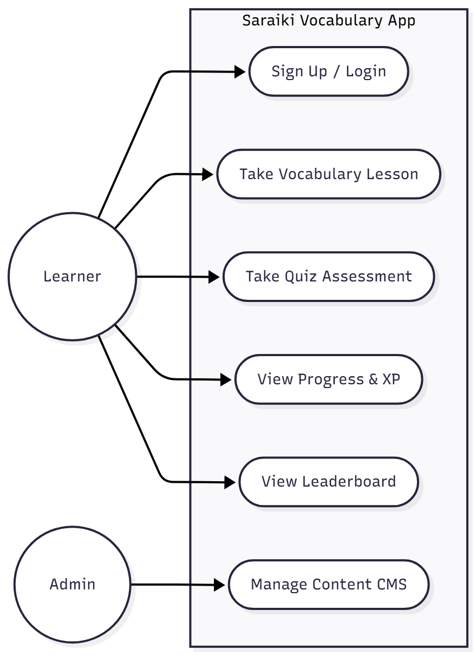
Figure 1: System Level Use Case Diagram

  - Use Case 1
ID | UC001
Name | Sign Up / Log In
Description | Allows a new Learner to create a unique profile for progress tracking, level advancement, and leaderboard ranking.
Requirement(s) | FR001
Actor(s) | Learner
Precondition | The Learner is accessing the application's initial authentication screen and does not have an existing account.
Postcondition | User account is created, and the Learner is navigated to the Home Screen.
Basic Flow | - Actor enter credentials  - System validates the inputs  - Following fields are required  - Email  - Password  - Username  - Check the proper inputs for following  - Email format  - Password must be minimum 6 characters  - Unique username  - System navigates the user to the Home Screen.  Alternative Flow  - Existing Account: If the entered email already exists, the system displays an error and prompts the user to log in.  Exceptions  - Invalid Input: If input validation fails (e.g., invalid email format or password under 6 characters), the system displays specific error messages next to the corresponding fields.

  - Use Case 2
ID | UC002
Name | Take Vocabulary Lesson
Description | Allows the Learner to view and listen to new vocabulary words using multimedia support.
Requirement(s) | FR002, FR007
Actor(s) | Learner
Precondition | The Learner is signed in and has selected a category (e.g., "Numbers").
Postcondition | The Learner has viewed the current vocabulary set, and the completion status may be tracked for streak purposes.
Basic Flow | - Actor selects a Category from the Home Screen.  - System retrieves the list of words, associated images, and audio files from local storage (or Firestore).  - System displays the Saraiki word and visual aid, and plays the audio file of pronunciation.  - Actor swipes to the next word.  - The process repeats until the end of the lesson is reached.  Alternative Flow  - Offline Access: If the Actor is offline, the system utilizes locally cached data and syncs progress upon reconnection.  Exceptions  - Audio File Missing: If the audio file for a specific word cannot be located, the system displays a "Pronunciation Unavailable" message and continues the lesson.

  - Use Case 3
ID | UC003
Name | Take Quiz Assessment
Description | Tests the Learner's retention of learned vocabulary through interactive quizzes and awards XP points upon completion.
Requirement(s) | FR003, FR004
Actor(s) | Learner
Precondition | The Learner has completed at least one vocabulary lesson.
Postcondition | Quiz score is calculated, XP is awarded, and user progress/gamification statistics are updated and synchronized.
Basic Flow | - Actor selects a quiz type.  - System retrieves the quiz questions.  - System displays a question.  - Actor selects an answer.  - System compares the answer against the correct data and calculates the score based on accuracy.  - Steps 3-5 repeat until the quiz is complete.  - System calculates the final XP earned and updates the Learner's Level and Streak counter.  - System displays the final score and a summary of correct/incorrect answers.  Alternative Flow  - Level Up: If the earned XP exceeds the Level threshold, the system displays a "Level Up" animation.  Exceptions  - Timeout: If the Actor exceeds the allotted time limit (if applicable), the system automatically submits the quiz and calculates the score based on completed questions.

  - Use Case 4
ID | UC004
Name | View Progress & XP
Description | Allows the Learner to monitor their personal learning statistics, including Level, XP points, and daily Streak.
Requirement(s) | FR004
Actor(s) | Learner
Precondition | The Learner is signed in.
Postcondition | The Learner's current progress is visually displayed.
Basic Flow | - Actor navigates to the dedicated Progress/Profile tab.  - System queries the Learner's profile data from Firestore (or local cache).  - System displays the Learner's current Level, XP bar, total XP, and active Streak count.  - System displays any recently unlocked achievements.  Alternative Flow  - Data Desynchronized: If the local progress cache differs from the Firestore data, the system forces a synchronization update to display the most accurate progress data.

  - Use Case 5
ID | UC005
Name | View Leaderboard
Description | Displays a ranking of users based on their total XP points to encourage competition and motivation.
Requirement(s) | FR005
Actor(s) | Learner
Precondition | The Learner is signed in.
Postcondition | A list of top users is displayed to the Learner.
Basic Flow | - Actor navigates to the Leaderboard tab.  - System queries the database for the top users, sorted by total XP points.  - System displays a list showing each user's Rank, Username, and Total XP. The Learner's rank should be highlighted.  Exceptions  - Network Error: If the system fails to connect to the database, it displays an error message stating, "Leaderboard Unavailable: Check connection."

  - Use Case 6
ID | UC006
Name | Manage Content CMS
Description | Allows the Admin to add, edit, or update vocabulary words, audio pronunciation files, and corresponding images.
Requirement(s) | FR006
Actor(s) | Admin
Precondition | The Admin is logged into the Content Management System.
Postcondition | New or updated vocabulary content is available for learners, and data is stored in Firebase.
Basic Flow | - Actor accesses the CMS console.  - Actor enters the Saraiki word, English translation, and assigns a Category.  - Actor uploads the corresponding image file and audio pronunciation file.  - Actor clicks "Submit."  - System validates the input files and metadata.  - System uploads media files to Firebase Storage and saves metadata to the Firestore database.  - System displays a confirmation message ("Word Added Successfully").  Exceptions  - Upload Failure: If the file upload fails (e.g., file size limit exceeded), the system displays an error message and prompts the Admin to retry.

Diagrams
The Activity diagram of each Use case is provided
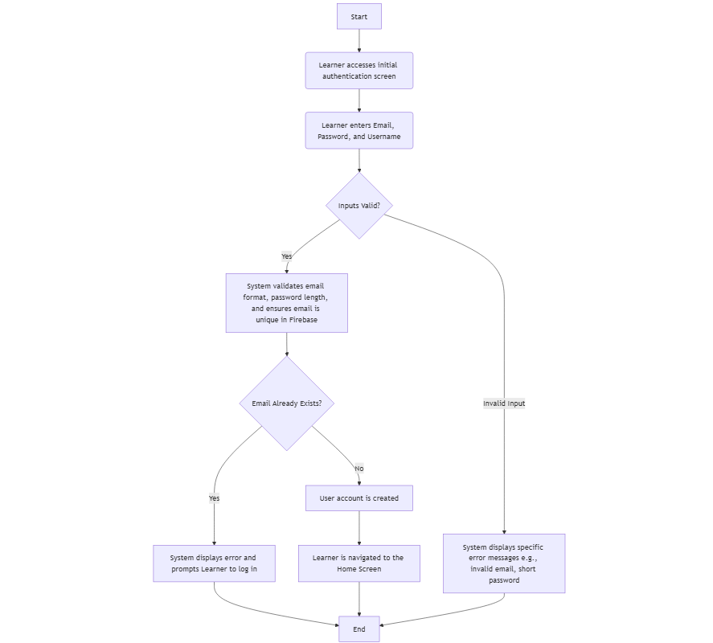
Figure 1.1: Sign Up / Log In

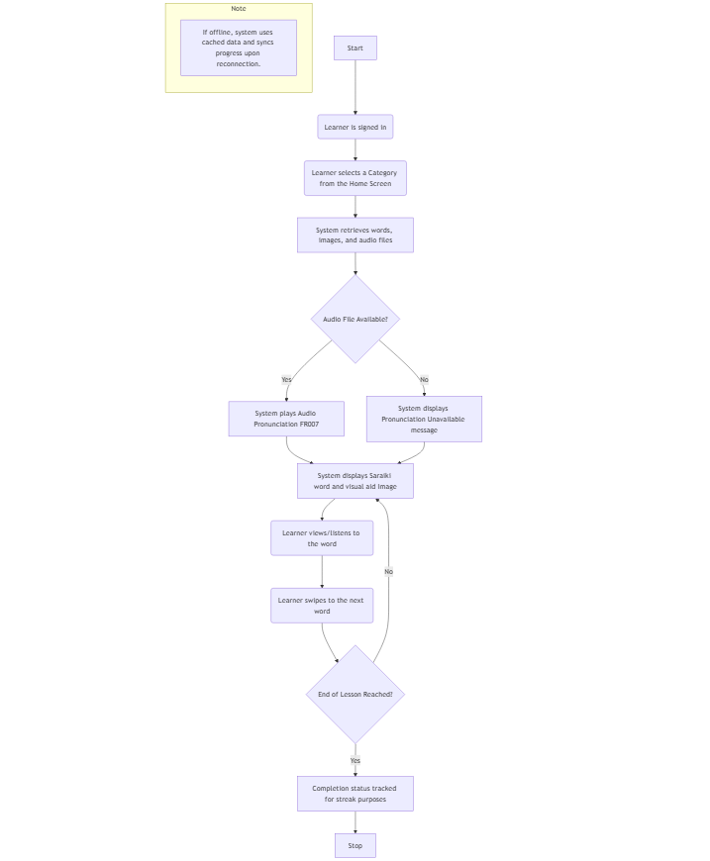
Figure 1.2: Take Vocabulary Lesson

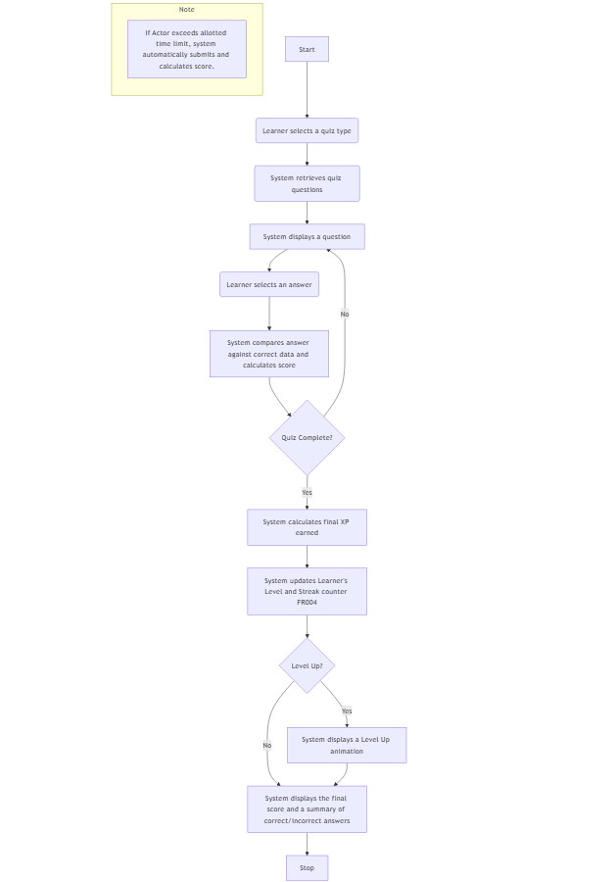
Figure 1.3: Take Quiz Assessment
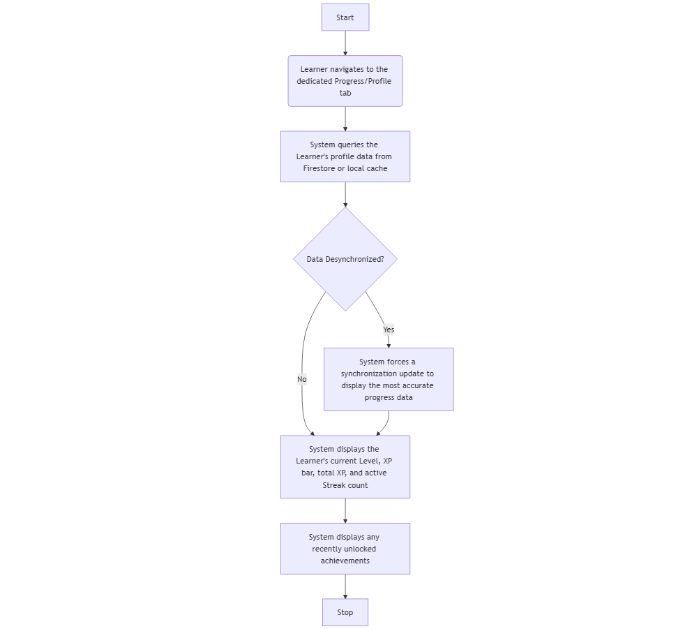
Figure 1.4: View Progress & XP

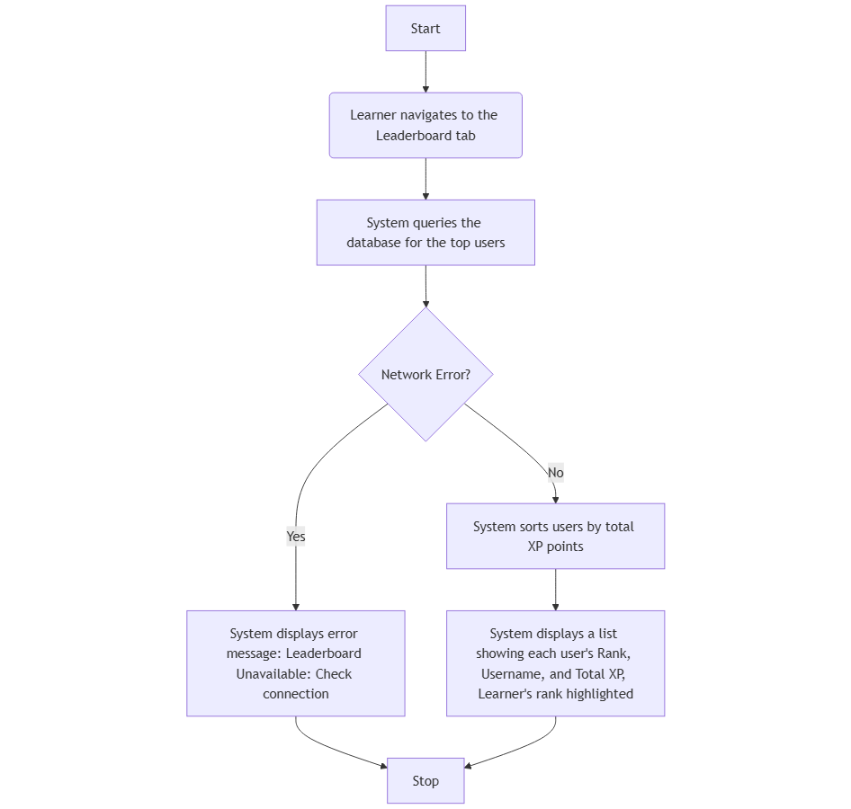
Figure 1.5: View Leaderboard

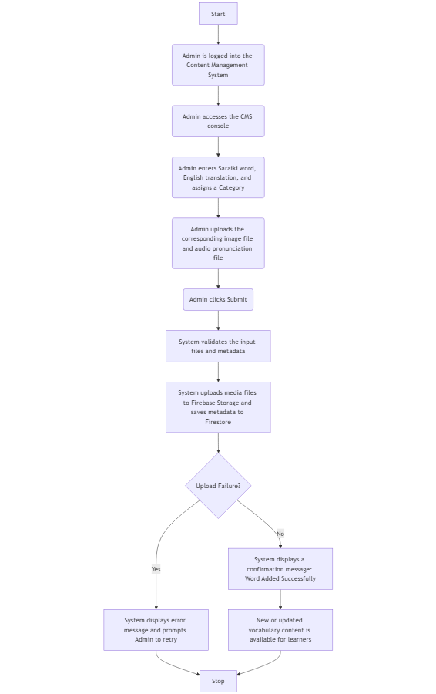
Figure 1.6: Manage Content CMS
- References
[1] J. Li, "Gamification in Mobile-Assisted Language Learning: A Study on Vocabulary Retention," Journal of Computer Assisted Learning, vol. 38, no. 2, pp. 120-135, 2022.
[2] X. Zhou and Y. Zhou, "Personalized Learning Environments in Mobile Education," International Journal of Mobile Learning and Organisation, vol. 18, no. 1, pp. 45-58, 2024.
[3] A. Dağdeler, "Preserving Underrepresented Languages through Digital Tools," Computer Assisted Language Learning, vol. 36, no. 3, pp. 200-215, 2023.

